Recording Train Service Status using Auckland Transport’s API
Clifford Dela Cruz
3/18/26

Objective
The objective of this project is to capture and analyse instances where Auckland’s train services (Eastern, Southern, Onehunga, and Western lines) stop operating due to unplanned faults or scheduled maintenance. As a regular commuter, I aim to build a dataset that helps explain the frequency and timing of these disruptions, particularly those occurring during peak office hours. The intention is not to criticise Auckland Transport, but to understand the underlying patterns and identify how often these service interruptions occur.

Challenges encountered
Initially, I explored the possibility of extracting disruption information through web scraping from the Auckland Transport train line status page. However, this approach was not feasible. The website relies on internal API endpoints that are not publicly accessible, meaning the data displayed on the site cannot be retrieved programmatically.

The Auckland Transport public API also presents limitations. It does not provide a direct feed of line-level disruptions or maintenance shutdowns. Instead, the real-time API only reports information at the trip level—specifically, whether a trip is running or cancelled. To work around this constraint, I ingest the full real-time feed and determine whether a train line has active trips. If a line has no active trips, it is classified as “stopped.”

To detect partial closures (for example, when only a segment such as Puhinui–Pukekohe is closed for maintenance), each trip is evaluated based on its start and end points. By checking the trip headsigns, I can determine whether the full route is operating or whether only part of the line is active.

Flowchart
This is a high-level description of the program flow

APIs used
The APIs I used are the following:

- Real Time compat – Trip Updates: this is used to take in all the train service updates. This will provide the information such as Trip ID, the Route ID, the status of the trip.

For this project, we are focusing on route ID and trip ID, as those contains the train line information as well as the trip information respectively.
URL: https://api.at.govt.nz/realtime/legacy/tripupdates[?callback][&tripid][&vehicleid]
Resource: https://dev-portal.at.govt.nz/api-details#api=gtfs-realtime-compat&operation=get_trip_updates

Prerequisites – need an API key (Ocp-Apim-Subscription-Key) which can be acquired by registering in https://dev-portal.at.govt.nz/

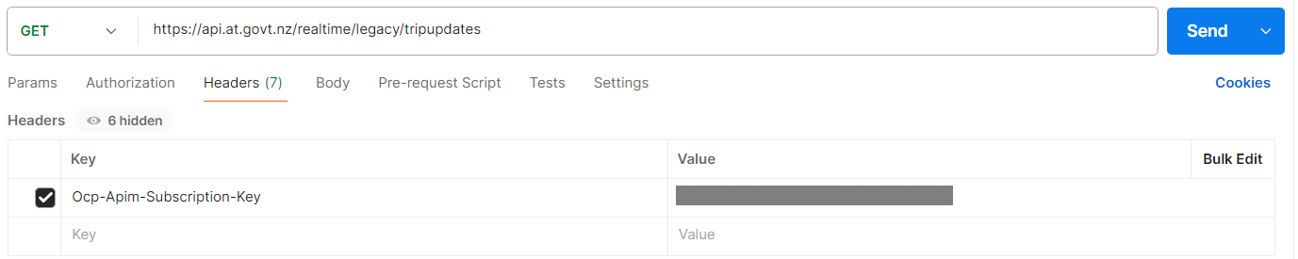

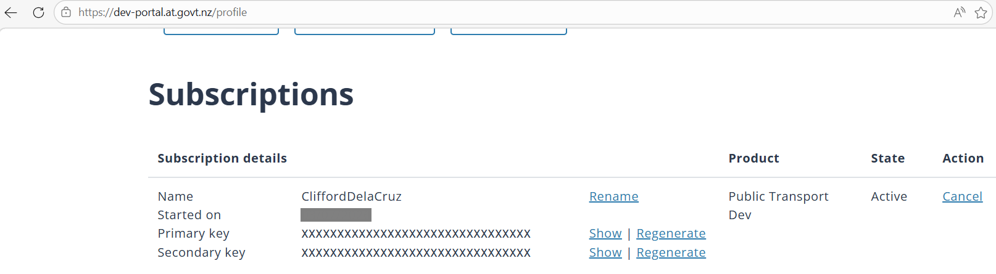

Sample images of key header input in Postman and subscription information
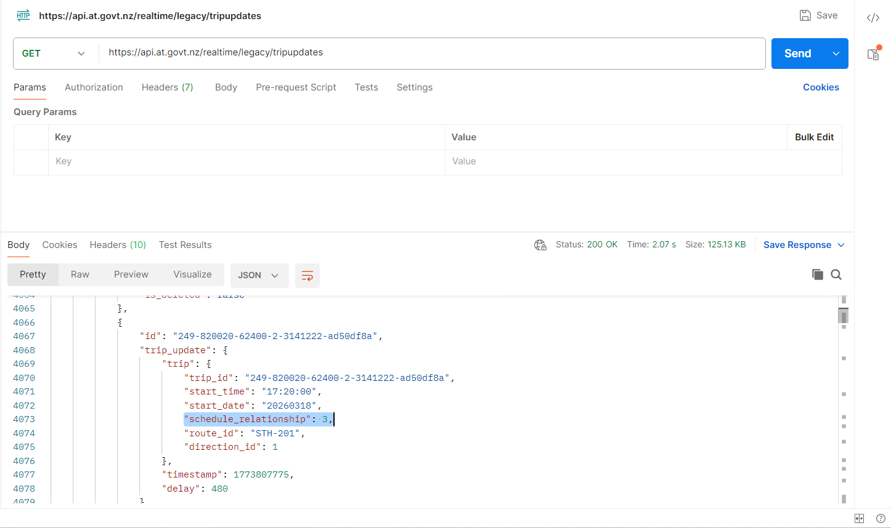
Example 1.1 This image shows one result of a trip in Southern line that is cancelled.
(schedule relationship = 3 means trip is cancelled)

- General Transit Feed V3 API – Trip by ID: this is used to identify the trip ID to indicate the services covered in that trip. Example, trip id 246-850001-30660-2-4234101-0620e5fd is an Eastern line service trip, which is a trip from Manukau to Britomart
URL: https://api.at.govt.nz/gtfs/v3/trips/{id}
Resource: https://dev-portal.at.govt.nz/api-details#api=gtfs-api&operation=get-trips-id

Prerequisites – need an API key (Ocp-Apim-Subscription-Key) which can be acquired by registering in https://dev-portal.at.govt.nz/

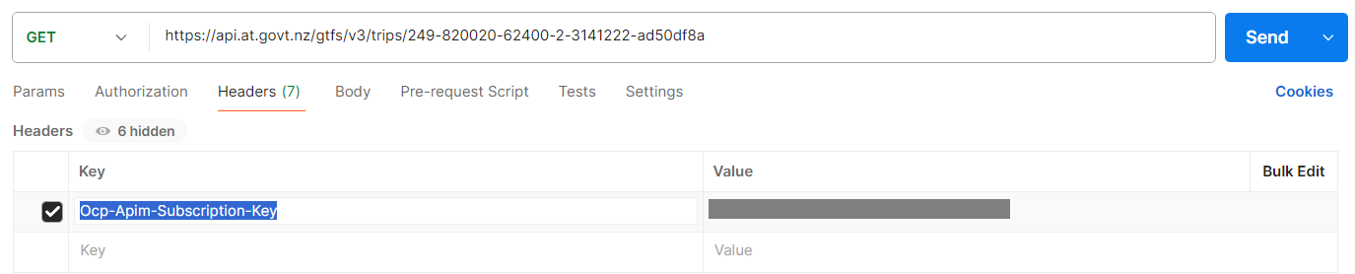


Sample images of key header input in Postman and subscription information

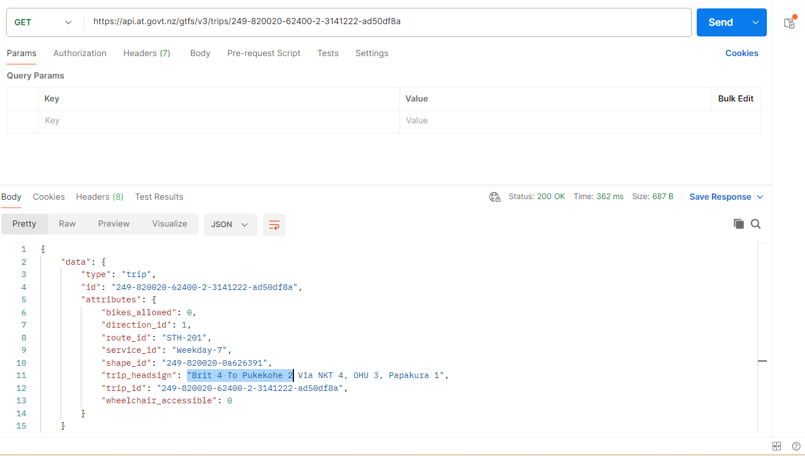
Example 2.1 This image shows that the trip information that it is a train service from Britomart to Pukekohe

Database setup
I used MySQL and created a schema “auckland_transport_db”
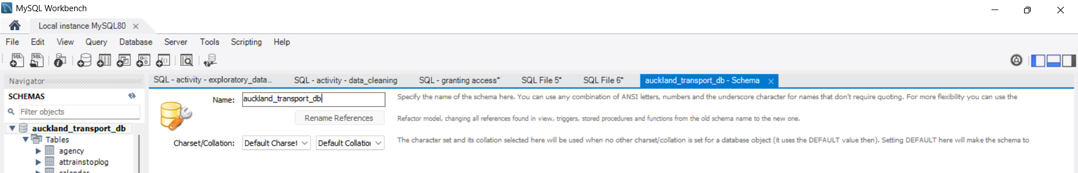

I created an account that can access the database and granted CREATE, DROP, SELECT, INSERT, UPDATE, DELETE role. This role will then be used in the program to be able to create and update a table “attrainstoplog”.
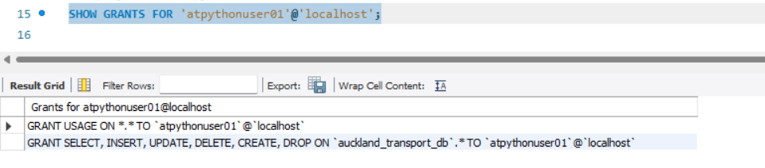

Running the “attrainstoplog” will show the information on the strain line during the program call
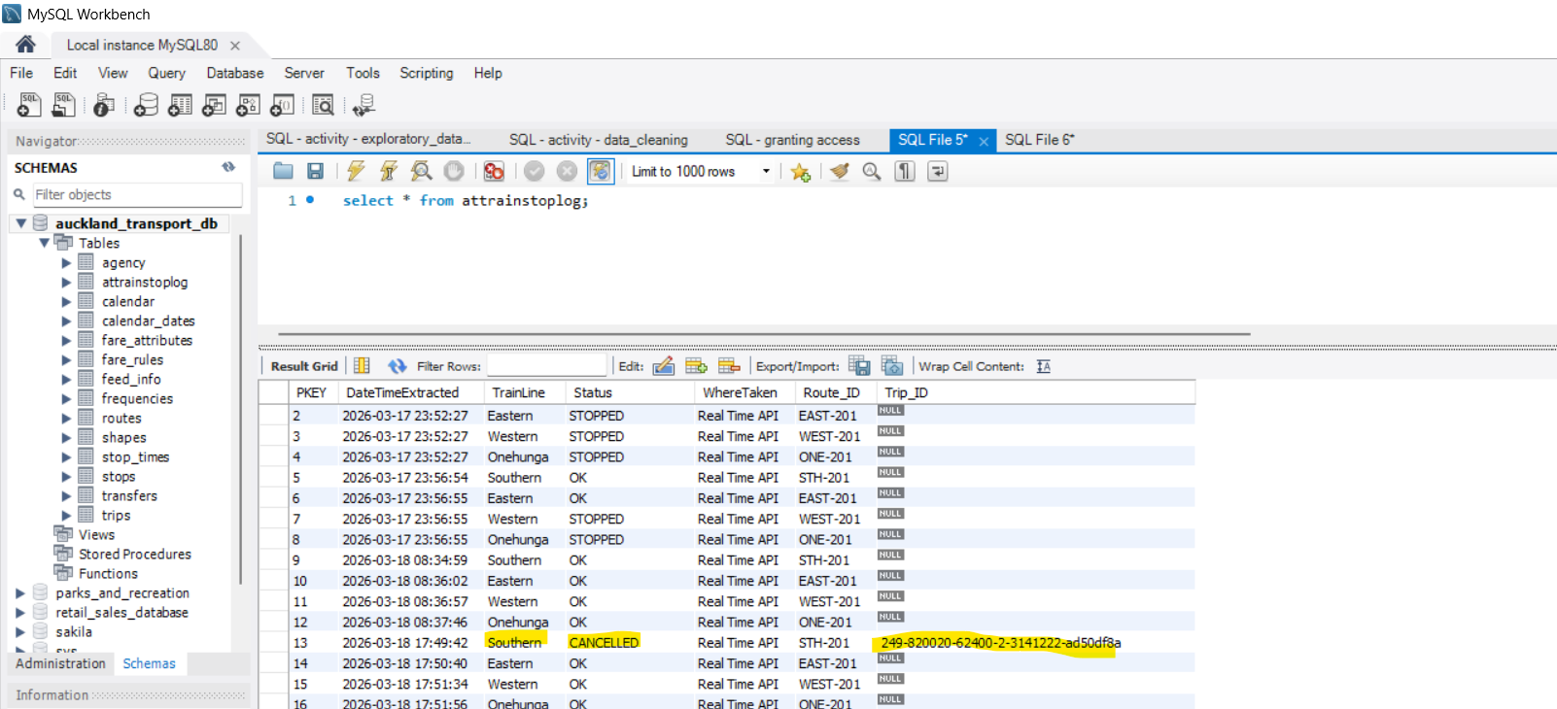

Logs are also created/updated to record the start of program run as well as the train status
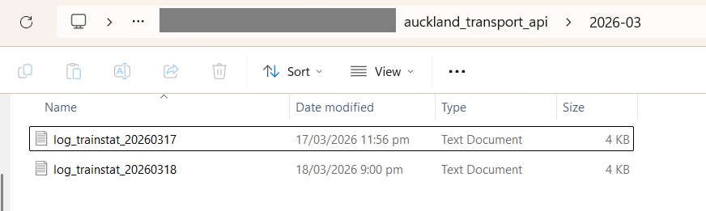

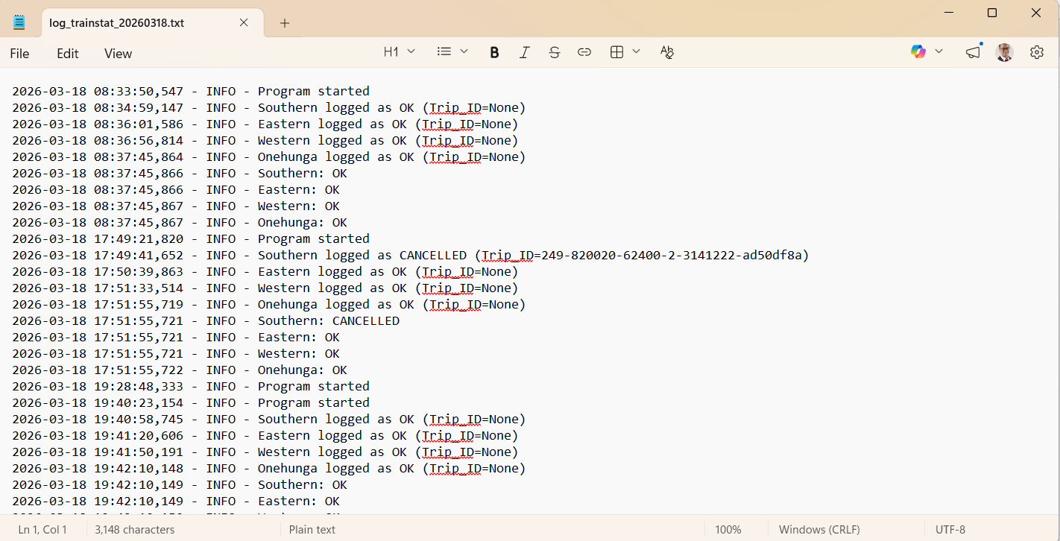

Further improvements and recommendations
To maximise the reliability and continuity of data collection, the program is best deployed in a server-based environment rather than run manually on a local machine. In the future, the solution will be migrated to a cloud platform (Azure), where the Python process can be executed on a scheduled basis and the resulting data automatically stored in a managed database service.

Additional links for reference
https://dev-portal.at.govt.nz/realtime-api
https://gtfs.org/documentation/schedule/reference/

